Introduction
This HDBaseT single network cable KVM extender transmits HDMI signal up to 70meters over cat6 fluently and clearly. It is lossless in signal and supports 3D, 24bits deep color, 4Kx2K, CEC and HDCP, It also allows access to a computer system from a remote console by USB connectors(USB keyboard and mouse).

Application
This KVM Extender is used to increase the distance betweenn a source(computer,CPU) and its console(keyboard, mouse, and other peripheral devices),It is useful for control and security purposes. Therefore it is wildly used in command center, data control center, operation rooms in military, bank, government, enterprise etc .

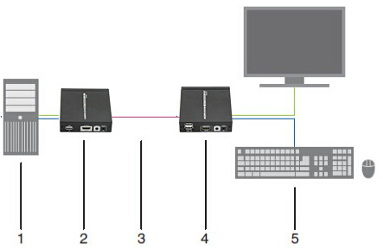
- Source: PC/computer
- LKV375KVM-TX unit
- CAT55/6/6A/7
- LKV375KVM-RX unit
- Console: Monitor,Keyboard,Mouse



Feature
Apply HDBaseT extend technology
Uncompressed HDMI video signal
Support full HD 1080p@60Hz, 3D, 4Kx2K
Extend 1080p signal over cat6a up to 70 meters
Support bi-directional IR pass back
support HDCP ,CEC, 24 deep color
Support uncompressed LPCM audio and compressed DTS-HD, Dolby True HD
Can be powered by network cable. It only needs to input 12V power for either transmitter or receiver for normal working.
Support KVM function

Appearance

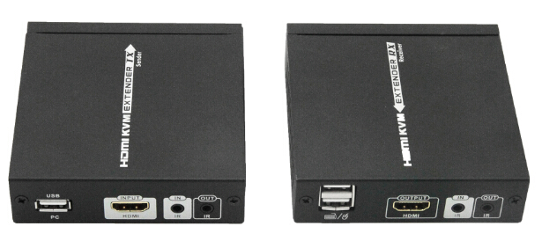
Function
HDMI to HDBaseT TX Sender
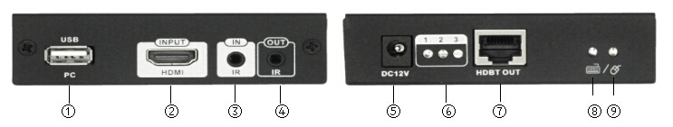
① USB port： Type A, connect with PC/computer
② HDMI IN:HDMI signal input to connect with HDMI source device.
③ IR IN:IR signal input to connect with IR receiver extension cable.
④ IR OUT:IR signal output to connect with IR blaster extension cable.
⑤ DC12V:Power input
⑥ Transmission signal indicator:
The first led: It is lighting on with power on.
The second led:When the sender connect the receiver working normal,the No2 lamp flashing status,and when input signal transmission normal the lighting keeps on.
The third led: It is lighting on when RX's HDMI OUT connects with HDMI display device and has HDMI signal output.
⑦ HDBT OUT:HDBaseT signal output
⑧ Keyboard connection indicator:
Light keep on: keyboard is connected
light flash：keyboard is under operation
⑨ Mouse connection indicator:
Light keep on: Mouse is connected
light flash：Mouse is under operation

HDBaseT to HDMI RX Receiver
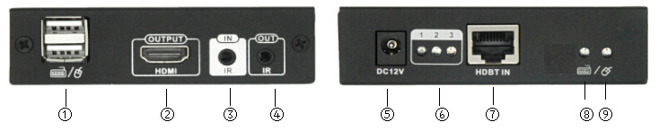
① USB port：Type A, connect with keyboard and mouse
② HDMI OUT:HDMI signal output to connect with HDMI display device.
③ IR IN:IR signal input to connect with IR receiver extension cable.
④ IR OUT:IR signal output to connect with IR blaster extension cable.
⑤ DC12V:Power input
⑥ Transmission signal indicator:
The first led: It is lighting on with power on.
The second led:When the sender connect the receiver working normal,the No2 lamp flashing status,and when input signal transmission normal the lighting keeps on.
The third led: It is lighting on when RX's HDMI OUT connects with HDMI display device and has HDMI signal output.
⑦ HDBT IN:HDBaseT signal input
⑧ Keyboard connection indicator:
Light keep on: keyboard is connected
light flash：keyboard is under operation
⑨ Mouse connection indicator:
Light keep on: Mouse is connected
light flash：Mouse is under operation

Specification
Part No. | LKV375KVM
Technical | Transmitter-TX | Receiver-RX
HDMI compliance | HDMI1.4
HDCP compliance | HDCP1.4
Transmission protocol | HDBaseT
Transmission distance | CAT5E/CAT6/CAT6A/CAT7
Transmission distance | CAT6： 1080p@60Hz 36bpp up to 70 meters  1080p@60Hz 48bpp&3D ， 4K×2K@30HzHz up to 40 meters  CAT5E：1080p@60Hz 36bpp up to 60 meters  1080p@60Hz 48bpp&3D ， 4K×2K@30HzHz up to 35 meters
Video support | 480i@60Hz、480p@60Hz、576i@50Hz、576p@50Hz、  720p@50/60Hz、1080i@50/60Hz、1080p@50/60Hz  4K×2K@24/25/30Hz
Audio support | LPCM, DTS-HD, Dolby Ture HD
InputTMDS signal | 0.7~1.2Vp-p
InputDDC signal | 5Vp-p
CEC | Supported
RS232 support | no
POH support | Supported, recommended to connnect the power adapter to the RX unit
latency | zero latency
supported configuration | point to point connection
IR passback | yes, bi-direction
IR frequency | 20-60KHz
Input | HDMI×1， 3.5mm jack(IR)×1， DC2.1×1  USB(typeA)×1 | DC2.1, RJ45×1， 3.5mm jack(IR)×1  USB(typeA)×2
Output | RJ45×1， 3.5mm jack(IR)×1 | HDMI×1， 3.5mm jack(IR)×1
HDMI source control | bi-direction IR
HDMI conector | Type A 19 Pins,Female
Network cable standard | CAT5E/CAT6/CAT6A/CAT7 , follow IEEE- 5688 standard
Mechanical | Transmitter-TX | Receiver-RX
Housing | Metal enclosure
Dimensions(L×W×H mm) | 99.45×94.5×25.7mm
Net weight | TX: 220g | RX: 230g
Power supply | 12V/2A
Power consumption | <8W | <8W
Operation temperaure | 0~50℃
Storage temperature | —10～70℃
Relative humidity | 0～95%(no condensation)

The first led: It turn on when power on.
The second led: It turn on when the transmitter unit and the receiver unit connect well with each other, and it flashes when there is no transmission between the transmitter unit and the receiver unit
The third led: It turn on when the receiver unit connect well with the HDMI display device, and It turn off when no transmission between the receiver unit and the display device

